CDU
Booking System
User Guide

Accessing the Application 3
Make a booking page 3
My bookings page 4
Notifications Page 4
All 5
To Approve 5
More info 5
Accepted 5
Requested 5
Rejected 6
Cancelled 6
Profile Page 6
How to make a booking single booking 6
How to make a recurring booking 12

Accessing the Application

Navigate to the CDU Portal (https://portal.cdu.edu.au).
Once at the Portal Login screen, sign in using your CDU credentials.
Access CDU Bookings via the “Room Bookings” tile:

Alternatively, you may access the application directly by navigating to https://bookings.cdu.edu.au in your browser.
You will be presented with a welcome screen, this will contain important notifications or information pertaining to Bookings.

To proceed to the application, click Log in:


Note: If you have already authenticated to the portal, clicking the log in button will automatically sign you in. If not, you will be directed to the CDU Sign in page as per below:

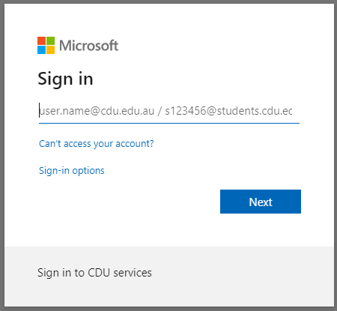
Once logged in you will be taken to the “Make a booking” landing page.

Make a booking page
You will be presented with the various bookable spaces available:
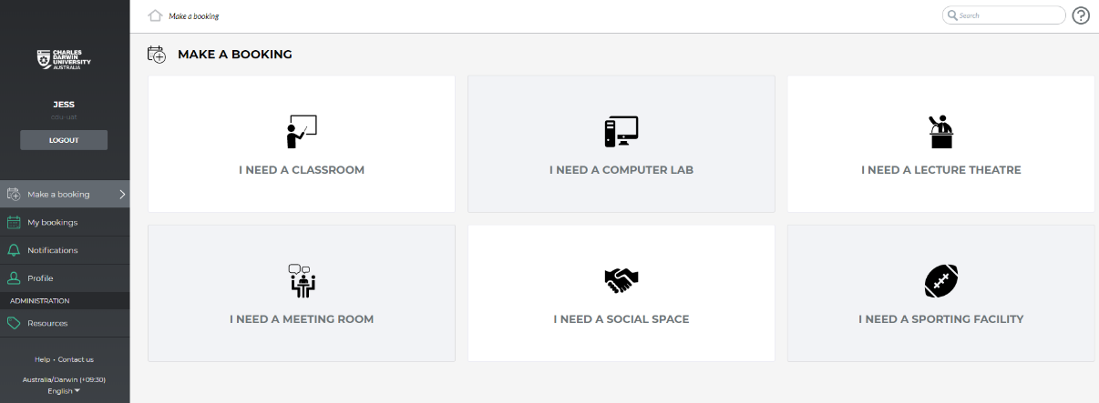

My bookings page
The “My bookings” page is where you can view all your bookings in either a calendar view (month, week, day) or as a list.
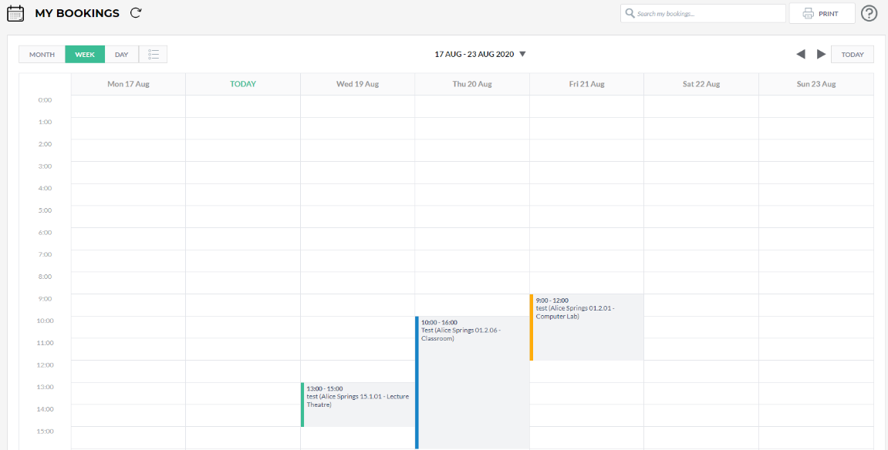

Note: The colour banner indicates the status of your booking, Green is approved, Blue is requested waiting approval and Orange is more info has been requested.

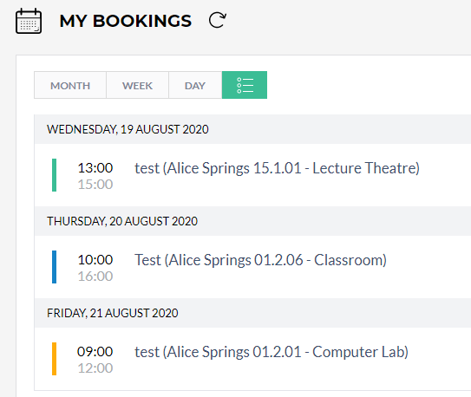

Notifications Page
The notifications page is where you can check the status of your booking, whether it has been Accepted, Rejected or if More Info has been requested in relation to the booking.

All
All the notifications you receive will show here.
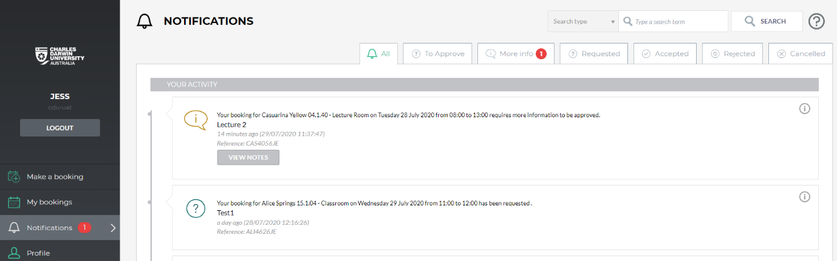

To Approve
Depending on your permissions, this where you can accept, reject or request-more-information on bookings.
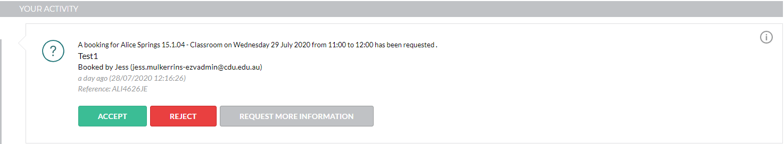

More info
Notifications for bookings where more information has been requested from the room approver. Click on “View notes” to find out what information has been requested.
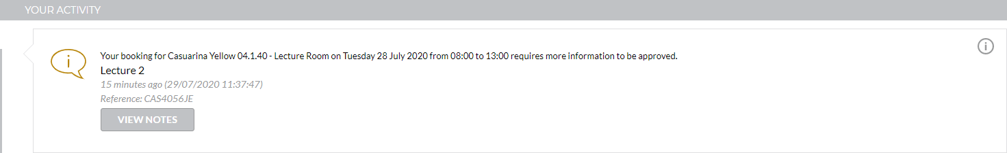

Accepted
This area shows notifications of confirmed bookings.
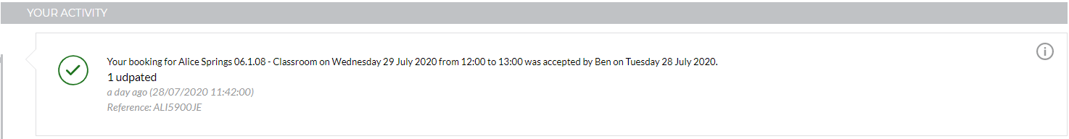

Requested
Booking requests that are still awaiting approval from the resource owner. 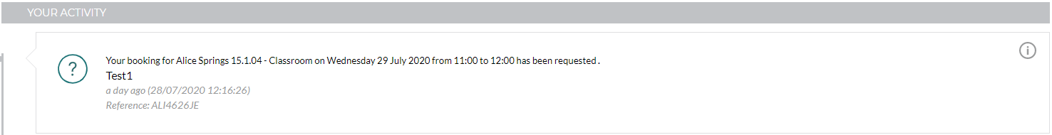

Rejected
This tab displays Booking request notifications that have been rejected.
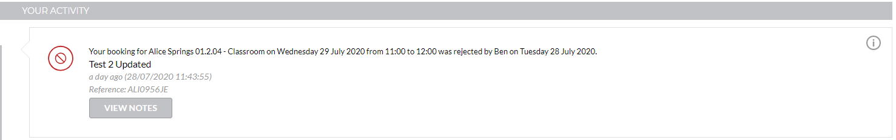

Cancelled
Notifications of bookings that have been cancelled by you or the resource owner.
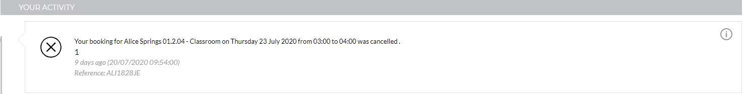

Profile Page
On this page you can set the language. 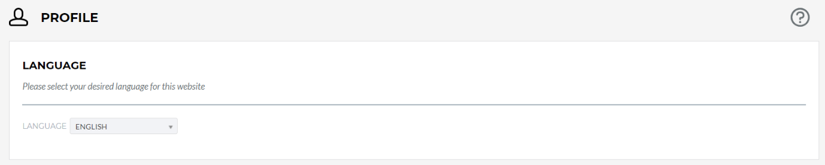

Note: The other information displayed on this page is used by the system to identify you.

How to make a booking single booking
- Navigate to the Make a booking page
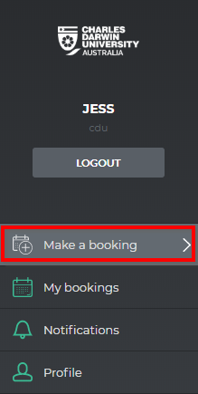

- Select the tile that best suits your needs i.e. “I Need a Classroom” 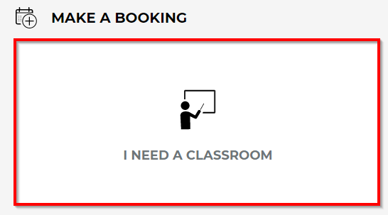

- Use the Refine Search options on the left to filter rooms:
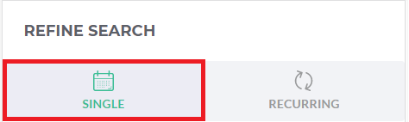 | Single/Recurring: Select single booking.
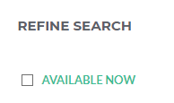 | Available Now:  Filter by Rooms that are available now.
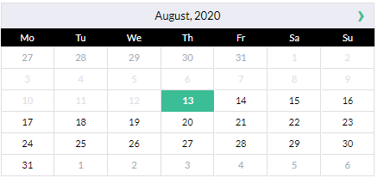 | Date:  Filter rooms by date.
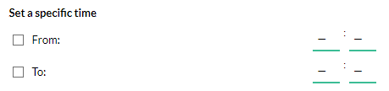 | Specific time:  Select a specific time.
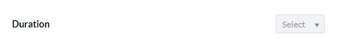 | Duration:  Duration of booking remember to account for extra time to setup/pack up.
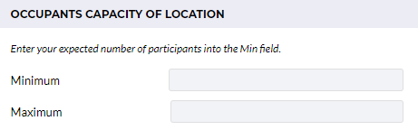 | Capacity:  Enter the expected number of occupants into the minimum field.
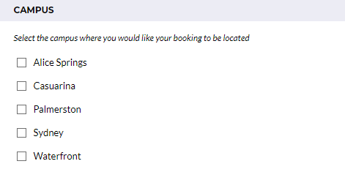 | Campus:  Select the campus you will be hosting your event/booking.
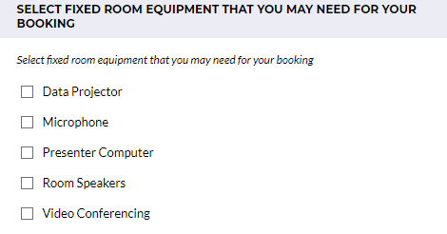 | Fixed room equipment:  Filter rooms by fixed room equipment such as Data Projectors and Presenter Computers.
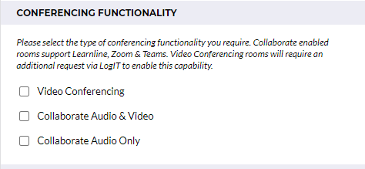 | Conferencing Functionality:  Filter rooms by Video Conferencing, Collaborate Audio & Video or Collaborate Audio Only. Please note Collaborate enabled rooms support Learnline, Zoom and Teams, if you require Video Conferencing you will be required to submit a Logit ticket.

- The filters you have applied will show above the list of the available locations. The list will change when you change the date, times or the other filters. 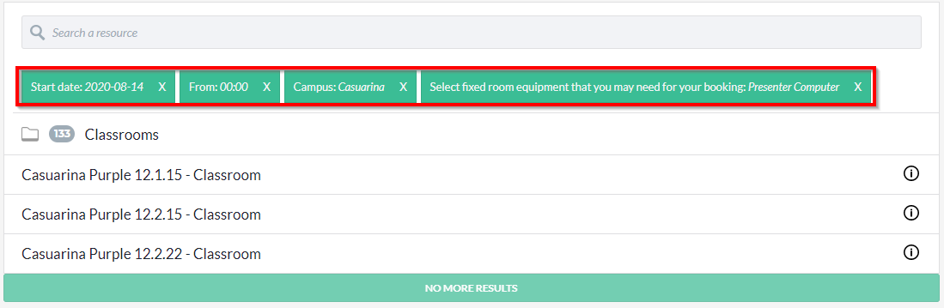

- Click the resource from the displayed list that you would like to book. 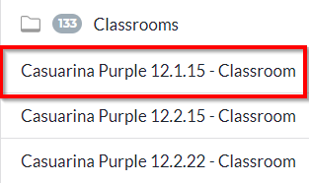

Note: If you have entered the date and times using the “Refine Search” you will be taken straight to the booking form, if not you will be taken to the Resources calendar. Please note that all bookings require a minimum of one days notice. See step 8.

- Once you select the resource, if you have not entered the date and time using the refine search you will be taken to that resources calendar.
Note: In the resource calendar you can change the view and date range as well as see the availability.
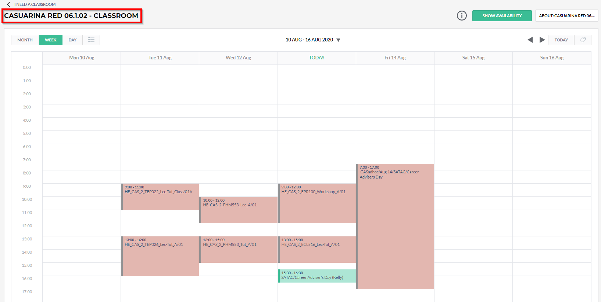
- Click a space on the calendar that corresponds with the time you want to book. This will open the booking form.

- Complete the booking form. Be aware that items marked with an asterisk are mandatory.

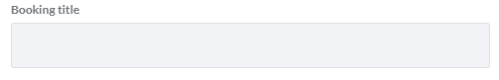 | Booking Title:  Name of your booking/event.
 | Single/Recurring: Select Single.
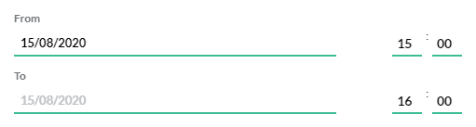 | From:  Date and time of your booking.
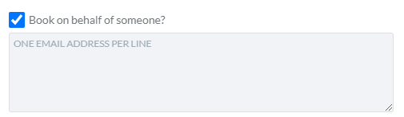 | Booking on Behalf of Someone:  Enter the email address/es of the person/s you are booking on behalf of.
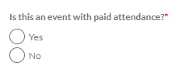 | Paid Attendance:  Select whether there will be a fee for attendees.
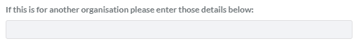 | Host details:  Please enter the name of the Organisation/business/student group or college hosting the event.
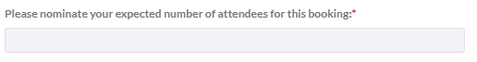 | Number of Attendees:  Enter the expected number of attendees.
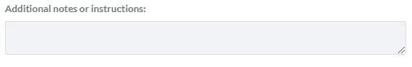 | Additional notes or Instructions:  Enter any additional notes/comments/instructions.
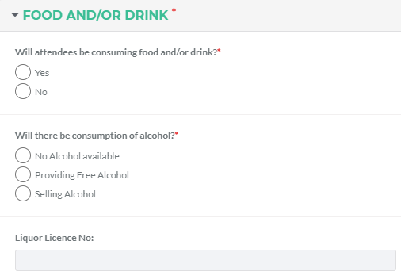 | Food and/or Drink:  Please nominate if attendees will be consuming food/drinks.  If there will be alcohol present, please enter your liquor licence.
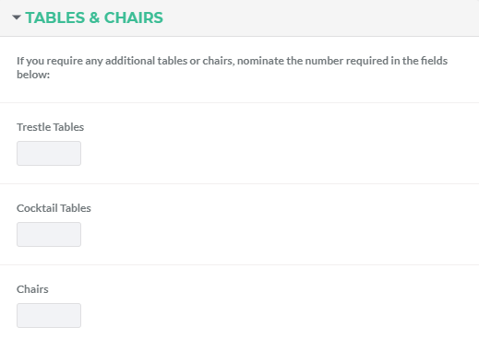 | Tables & Chairs:  Nominate the required number of additional tables/chairs required.
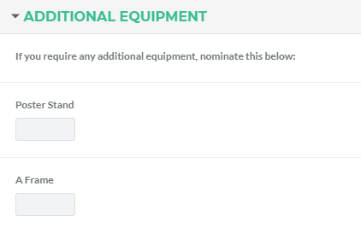 | Additional Equipment:  Nominate the number of additional equipment required.
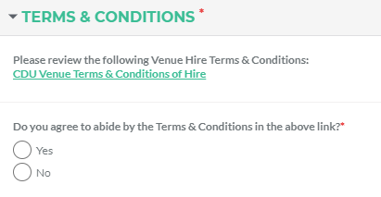 | Terms & Conditions:  Please follow the link and read the CDU Venue Hire Terms & Conditions. You will be required to agree to these before you can submit your booking.

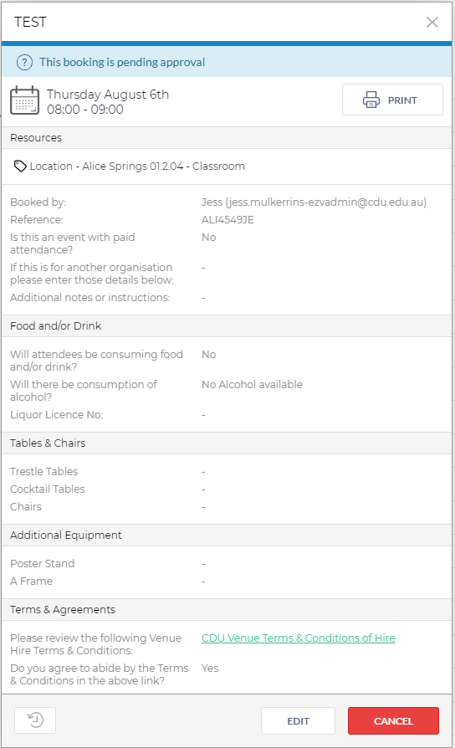
- Once you have filled out all the mandatory items select the “Book” button this will submit your booking for approval. Please note that bookings made outside of business hours will not be reviewed until business recommences (Mon-Fri 8:00am to 4:21pm ACST).

- To check the status of your bookings, navigate to Notifications you will also receive an email informing you of the status of your booking as it progresses.
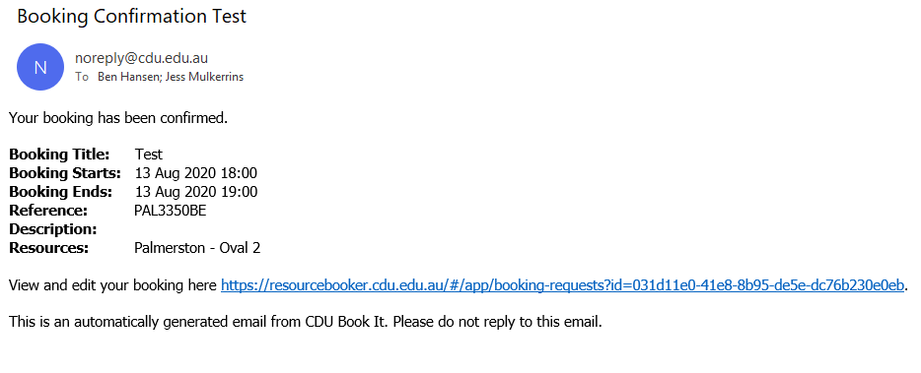

How to make a recurring booking

- Navigate to the Make a booking page

- Select the tile that best suits your needs i.e. “I Need a Classroom”

Use the Refine Search options on the left to filter rooms:
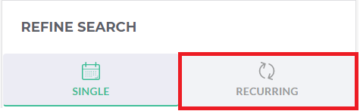 | Single/Recurring: Select recurring booking.
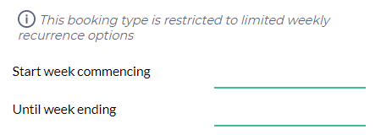 | Week commencing/ending:  Using the calendar select the dates corresponding to the start and end of your booking.
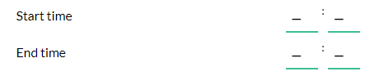 | Start/End Time:  Select the start and end time of your desired booking.
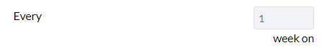 | Every: Enter the frequency of the booking in weeks.
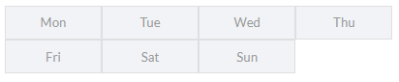 | Days: Select the days you wish your booking to occur on.
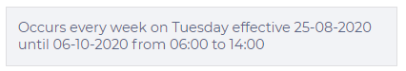 | Confirmation: Confirm the information you entered is correct.
Capacity:
Enter the expected number of occupants into the minimum field.
Campus:
Select the campus you will be hosting your event/booking.
Fixed room equipment:
Filter rooms by fixed room equipment such as Data Projectors and Presenter Computers.

Conferencing Functionality:
Filter rooms by Video Conferencing, Collaborate Audio & Video or Collaborate Audio Only. Please note Collaborate enabled rooms support Learnline, Zoom and Teams, if you require Video Conferencing you will be required to submit a Logit ticket.

- Click on “Search Recurring”
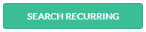

- Click the resource from the displayed list that you would like to book.

Note: If you have entered the date and times using the “Refine Search” you will be taken straight to the booking form, if not you will be taken to the Resources calendar. Please note that all bookings require a minimum of one days’ notice.

- Once you select the resource, if you have not specified the dates and times of your recurring booking using the refine search you will be taken to that resources calendar.
Note: In the resource calendar you can change the view and date range as well as see the availability.

- Click a space on the calendar that corresponds with the time you want to book. This will open the booking form.

- Complete the booking form. Be aware that items marked with an asterisk are mandatory.

Booking Title:
Name of your booking/event.
 | Single/Recurring: Select Recurring.
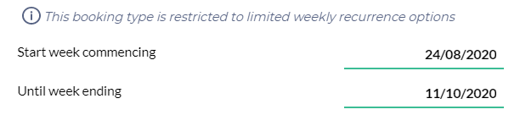 | Week commencing/ending:  Using the calendar select the dates corresponding to the start and end of your booking.
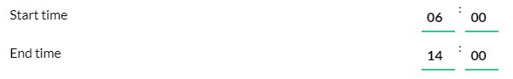 | Start/End Time:  Select the start and end time of your desired booking.
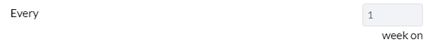 | Every: Enter the frequency of the booking in weeks
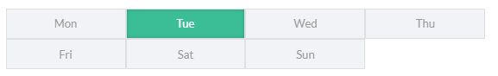 | Days: Select the days you wish your booking to occur on.
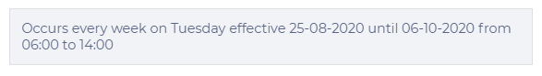 | Confirmation: Confirm the information you entered is correct.
Booking on Behalf of Someone:
Enter the email address/es of the person/s you are booking on behalf of.
Paid Attendance:
Select whether there will be a fee for attendees.
Host details:
Please enter the name of the Organisation/business/student group or college hosting the event.
Number of Attendees:
Enter the expected number of attendees.
Additional notes or Instructions:
Enter any additional notes/comments/instructions.
Food and/or Drink:
Please nominate if attendees will be consuming food/drinks.
If there will be alcohol present, please enter your liquor licence.
Tables & Chairs:
Nominate the required number of additional tables/chairs required.
Additional Equipment:
Nominate the number of additional equipment required.
Terms & Conditions:
Please follow the link and read the CDU Venue Hire Terms & Conditions. You will be required to agree to these before you can submit your booking.

- Once you have filled out all the mandatory items select the “Book” button this will submit your booking for approval. Please note that bookings made outside of business hours will not be reviewed until business recommences (Mon-Fri 8:00am to 4:21pm ACST).

- To check the status of your bookings, navigate to Notifications you will also receive an email informing you of the status of your booking as it progresses.
